**Chopta tungnath chandrsila trek**

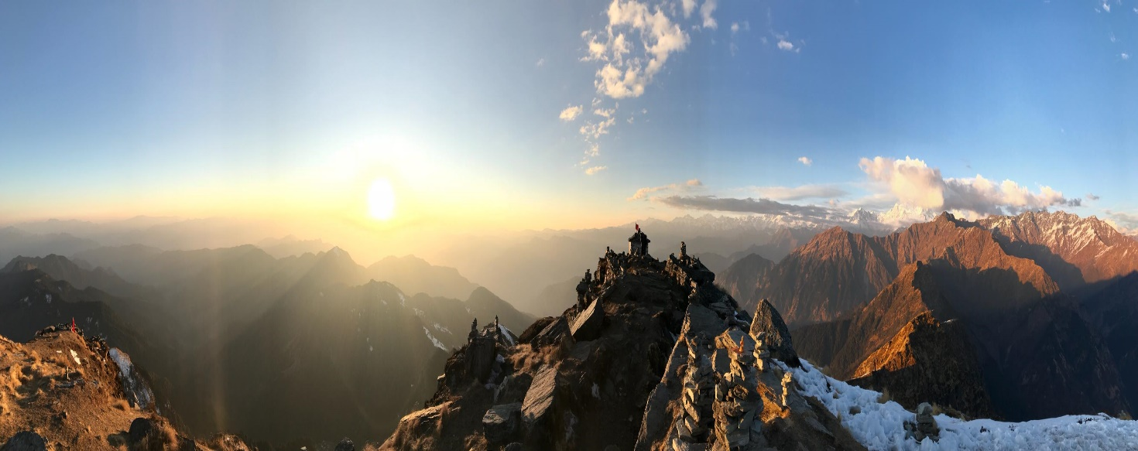

Pic : Chandrsila peak

**Chandrashila** is summit of the [Tungnath](https://en.wikipedia.org/wiki/Tungnath) . It literally means "Moon Rock". It is located at a height of about 4,000 metres (13,000 ft) above sea level. **Chandrashila Trek with Chopta and Tungnath** is one of the most exciting and challenging trails you can tread in Uttarakhand.Soaring up at 13000 feet, adorned with mists, coniferous, and snow, this is one heck of a trek you must take.

This peak provides a spectacular view of [Himalayas](https://en.wikipedia.org/wiki/Himalayas), especially [Nandadevi](https://en.wikipedia.org/wiki/Nandadevi), [Trisul](https://en.wikipedia.org/wiki/Trisul), Kedar Peak, [Bandarpunch](https://en.wikipedia.org/wiki/Bandarpunch) and [Chaukhamba](https://en.wikipedia.org/wiki/Chaukhamba)peaks.

The trek to the peak is 5 km. The trek route that starts from [Chopta](https://en.wikipedia.org/wiki/Chopta) takes one to [Tungnath](https://en.wikipedia.org/wiki/Tungnath) (highest Shiva temple in the World), from here it is a kilometre long, and a steep trek. Though shorter in distance, steep climbing makes this trek rigorous.

**IF YOU ARE BEGINNER THAN THIS IS THE RIGHT TREK TO STRAT YOUR JOURNEY, ALSO IF YOU ARE FIRST TIME IN LAPS OF GARHWAL HIMALAYS THAN THIS TREK GIVE YOU AN UNFORGETTABLE EXPERIENCE AND GREAT MEMORIES** .

**Trek Details:**

This trek is done by following route.

**Trek route 1: Haridwar / Rishikesh- Sari village – Devriyataal – Chopta – Chadrsila-Chopta (4 night 5days or 3night and 4 days** depending upon trekkers  **)**

**Trek route 2: Haridwar / Rishikesh – Chopta – Chadrsila-Chopta (2night 3days )**

**Trek route 1:**

**Day 1 - Drive from Haridwar to Sari (6 Hours)-** Sari, the base camp of the Deoriatal-Chandrashila trek, is an 8 hour drive from Haridwar.

### **Day 2 - Drive from Haridwar to Sari (6 Hours), Trek from Sari to Deoriatal (2,438m) –**

### **Sari to Deoriatal**

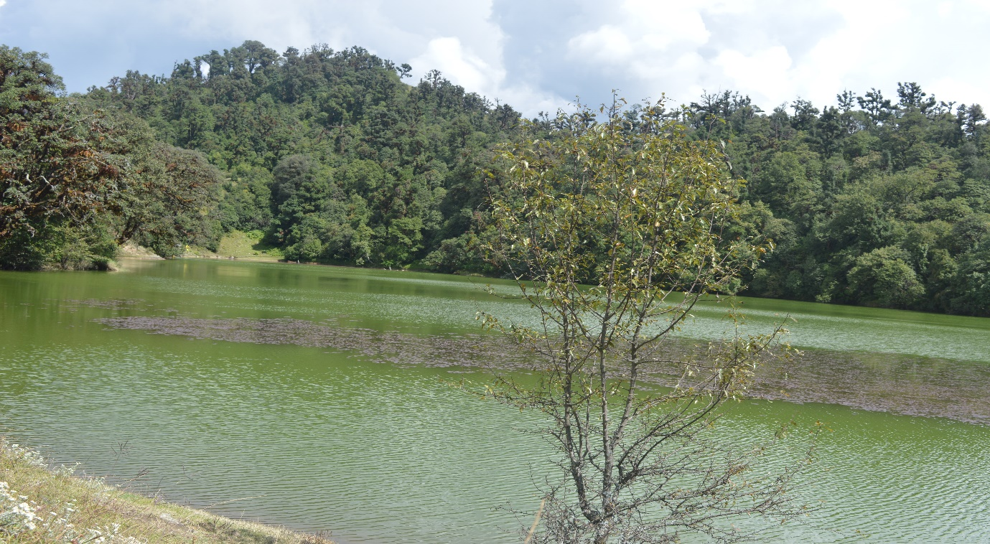

Pic : Devriyataal

* **Altitude:**6,601 ft (2012 m) to 7,841 ft (2,390 m)
* **Time taken:**1 hour, 3 km
* **Trek gradient:** Easy. Gradual climb on a well-defined rocky trail, which becomes steeper after the first 10 minutes. Short descent to the camp site after an hour of climbing.
* **Water sources:** None. Carry around 1 litre of water from Sari.

### **Day 3: Deoriatal to Chopta**

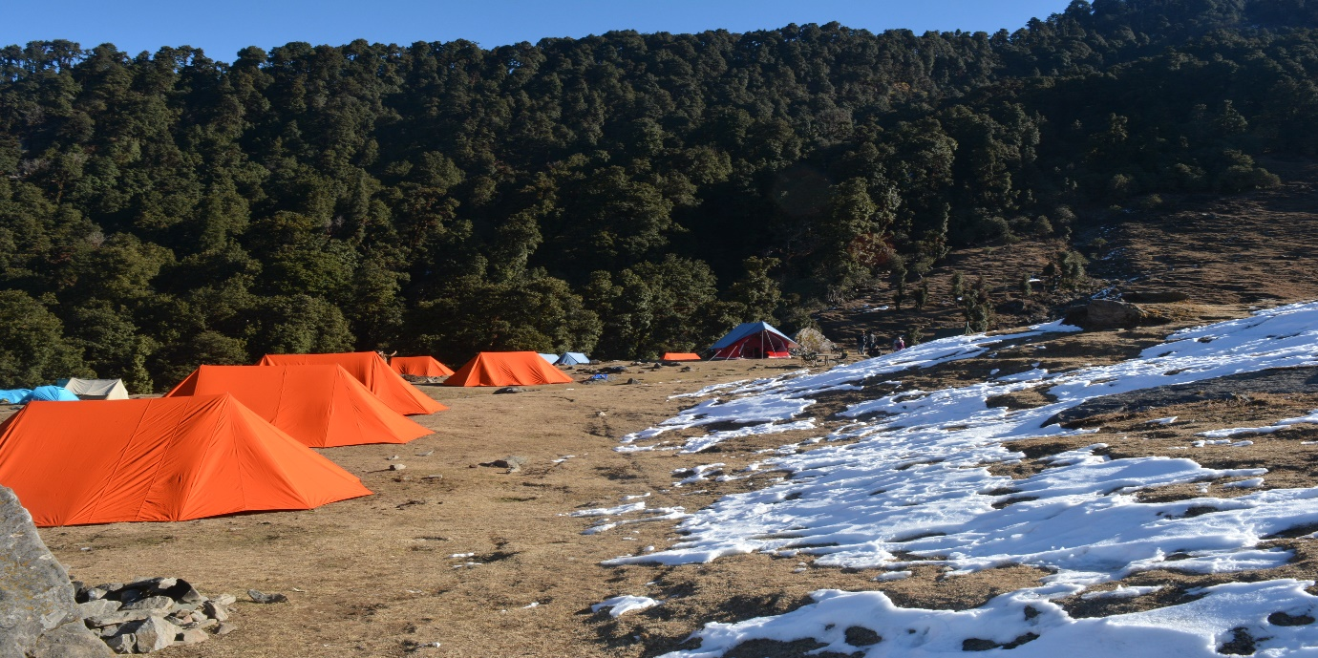

Pic : Devbhoomi Camp at chopta

* **Altitude:**7,841 ft (2,390 m) to 8,790 ft (2,679 m)
* **Time taken:**7-8 hours, 14 km
* **Trek gradient:** Moderate. Initial 45 minutes of gradual ascent followed by 40 minutes of rapid descent, easing off after an hour of ascent to reach Rohini Bugyal. Series of ascents and descents to Chopta – 20-30 minutes each.
* **Water sources:** Carry 2 litres of water from Deoriatal. Your first water source will be around 20 minutes before Rohini Bugyal, which could be frozen in winter. Other sources are  Akash Kamini waterfall en route Bhrujgali and a brook before Bhrujgali.

### **Day 4: Chopta to Chandrashila Peak via Tungnath and back to Chopta**

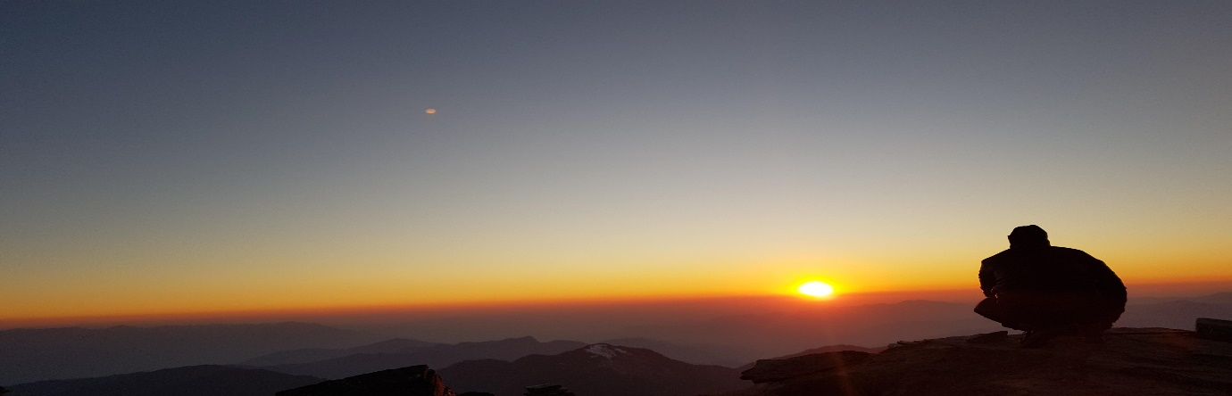

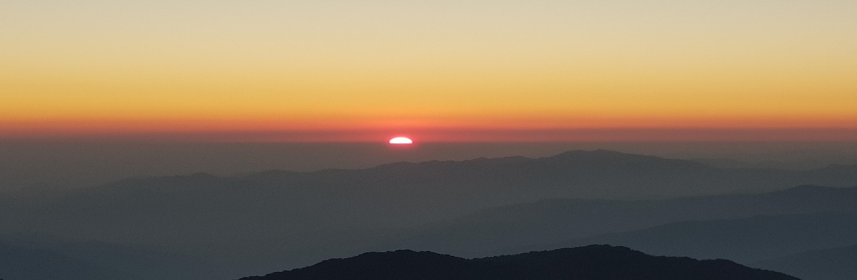

Pic : sunset at Chandrsila peak , winter line phenomena

* + **Altitude:**8,790 ft (2,679 m) to 12,083 ft (3,683 m)
* **Time taken:**4 hours, 8 km
* **Trek gradient:** Moderate. Sharp ascent to Tungnath (2 km) followed by steep climb to Chandrashila for about 45 minutes. Descent on the same path takes around 90 minutes.

### **Water sources:** None. Ensure you are well hydrated and carry 2 litres of water while starting from Chopta

### **Day 5:  Depart for Your destination**

**Trek route 2:**

**Day 1**: From Haridwar to Chopta by Road

**Day 2**: Chopta – Tungnath – Chandrsila – back to Chopta

**Day 3**: Start your journey at early morning to devarilya lack. Trek point start from Sari village (12KM from chopta ) and then Trek of 3km,.

* explore lake area and come back to sari village. Finally departure to your destination.

**TREK PACKAGES: (including camping, food ,beverage, forest pass, Authority permission, walking sticks & other camping gears )**

**4 night 5days: 7999* INR per person**

**3night and 4 night: 6499* INR per person**

**2 night 3 days : 4999* INR per person**

**( * Transportation cost extra)**